2014 Slope Survey: Bitter Crab – Kodiak-Pathobiology

Obtain a blood smear & blood sample from *Chionoecetes opilio* and *C. bairdi* at any station regardless of location and depth. Sample **all *C. opilio***; sample **100 *C. bairdi* males** and **100 *C. bairdi* females** (random sample of all size classes). Collect **every** BCS visually positive *Lithodes aequispina*. Crabs can be kept in baskets in the live tank until you are ready to sample.

1. Enter collected crab data onto datasheets. Include: cruise number, vessel, general location (i.e. Slope), leg, haul, plate number, your name. Crab morphometrics: sex, species, size (carapace **width or** **length** in **mm**), shell condition, chela height and **note if crab looks visually BCS+**. To note haul number fill in the blank at the beginning and end of each row on the datasheet, if the haul number changes in that row, draw a dark line between the boxes. The boxes on the left correspond with the haul number on the left and the boxed on the right correspond with the haul number on the right.

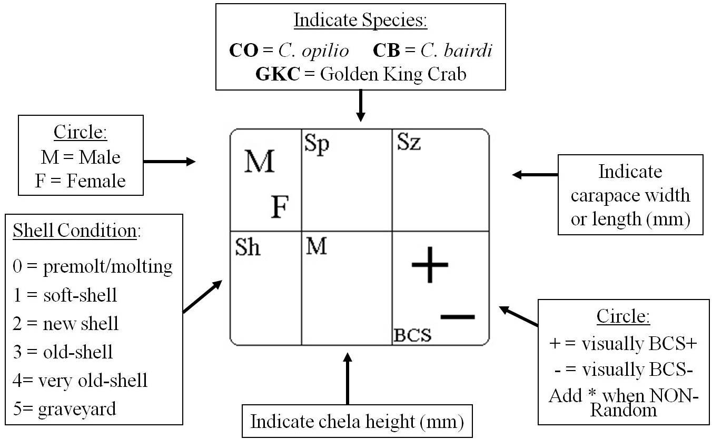

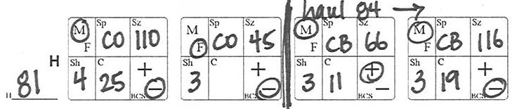

1. Obtain a clean syringe with attached needle. Choose a region of the crab where the arthrodial membrane is exposed and insert the needle (a good spot is where the legs meet the carapace). Pull back on the plunger to extract hemolymph, you may need to move the needle around to locate a sinus. **Collect just *slightly* more than 0.2mL hemolymph!** If the hemolymph is brownish/yellow, you have sucked up hepatopancreas with the blood and the sample must be discarded. Obtain a new syringe and try again.
2. Invert the syringe and tap the side to dislodge air bubbles. With the needle facing up remove as much air from the sample as possible by depressing the plunger.
3. In pencil, write the **collection plate & well number** on the white frosted end of a new microscope slide (i.e. 33-A5)
4. Using the syringe, dispense 1-2 drops (approx. 4 mm in diameter) of hemolymph near the edge of the *non*-frosted end of the microscope slide. Take a “smearing” slide, place it at a 30o-45o angle, pull it back so that it touches the drop of blood and then move it toward the frosted end of the slide with a smooth and steady motion. Drag blood, don’t push it (see figure below). Use **one end** of “smearing” slide per smear, so two smears can be made with each “smearing” slide. Set smears aside and allow to dry, try to avoid all water splash while making smears on deck! Smearing slides can be disposed of in the containers labeled “Used Smearing Slides”. When the container is full, cover the opening and tape the lid to the container for shipping back to Seattle with gear.
5. Next, insert the needle into a colored well plug of the collection plate and eject the hemolymph into the pre-filled ethanol (see below). Pull out the needle (the well plug will reseal itself). If you find that the plug is loose or comes out, try removing air from the well with the syringe before injecting the hemolymph sample. Do not remove any ethanol. **Do not use wells A12, B10, D3, G5 & F8** (**grey** caps, they will be used as controls).
6. Remove needle from the syringe using the needle remover on the sharps container, trap the plastic part of the needle in the “V” and twist off the syringe. Dispose of syringes into plastic bags (put back into yellow barrel when full).
7. Periodically **invert the plate** to mix the hemolymph and ethanol. When a plate is full, replace in Ziploc bag and seal. Stack and store in a gray 5-gal bucket.
8. After the slides are completely dry, place in slide box. Two slides may be place in each slot of slide box, if they are placed **back-to-back**. For shipping: place a couple of paper towels on top of slides, secure lid and tape boxes closed.

“Smearing” Slide

